**ANIRUDH.R(192011013)**

**30. Junit Testing to check whether the given number is palindrome or not**

**AIM**

To Perform junit Testing to Check Whether the given number is palindrome or not.

**PROGRAM**

**package** sse;

**import** java.util.Scanner;

**import** **static** org.junit.Assert.*assertTrue*;

**public** **class** palindrome

{

**public** **static** **void** main(String args[])

{

Scanner in = **new** Scanner(System.***in***);

**int** r, sum = 0, temp; **int** n = in.nextInt();

temp = n;

**while** (n > 0)

{

r = n % 10; n = n / 10;

sum = (sum * 10)+r;

}

System.***out***.println(sum);

*assertTrue*(787==sum);

**if**(temp==sum)

System.***out***.println(sum+" is palindrome number");

**else**

System.***out***.println(sum+" is not palindrome number");

}

}

**OUTPUT**

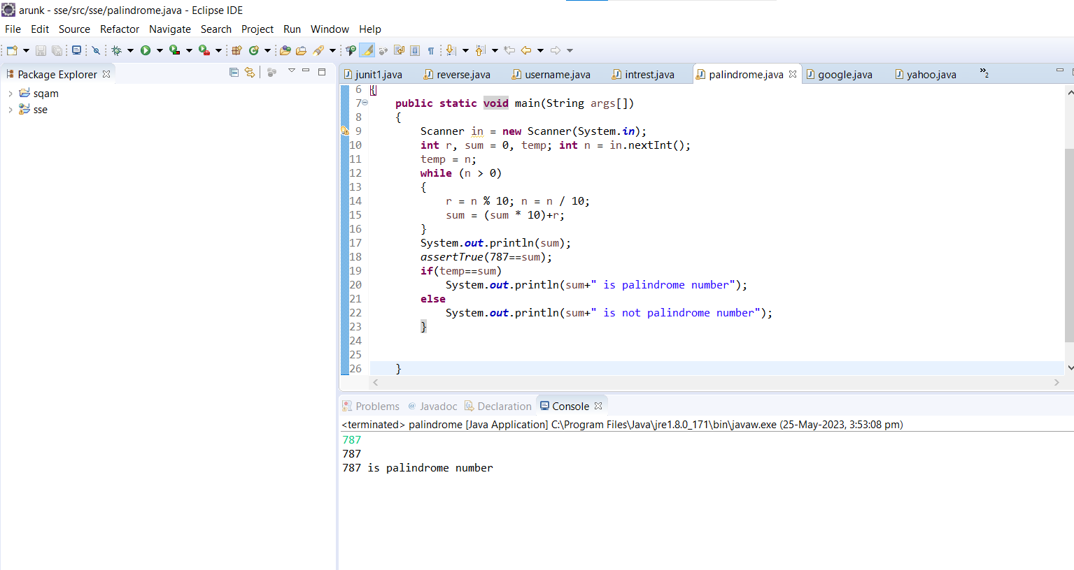

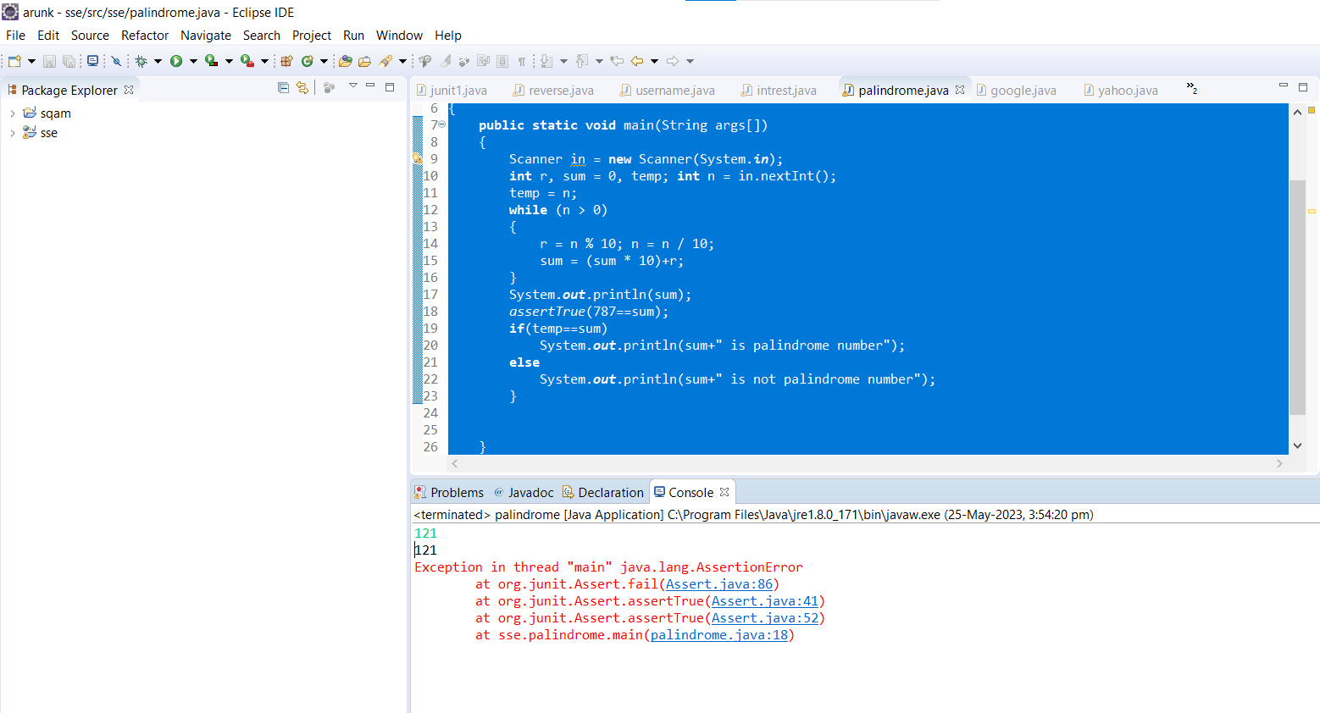

**RESULT**

Hence the junit Testing Check Whether the given number is palindrome or not performed successfully.